Strategic Factory’s End-to-End Workflow Uncovered in Upcoming Webinar
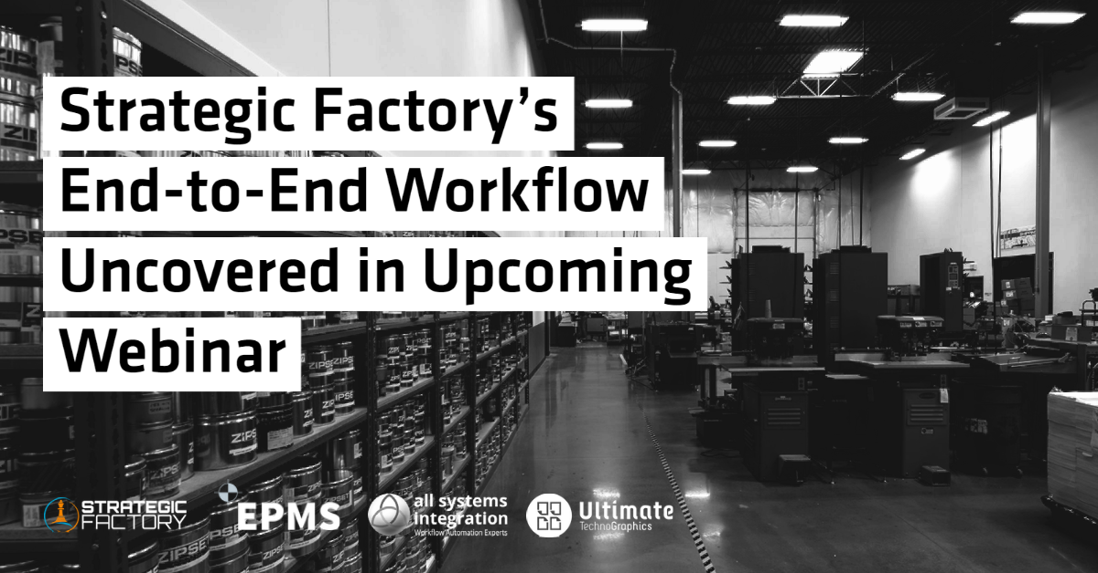
Montreal, Canada, Middleboro, MA. Newton Centre, MA. November 14, 2022, Ultimate TechnoGraphics, leader in imposition and finishing automation software, Enterprise Print Management Solutions (EPMS), a market leading developer of print MIS, and All Systems Integration (ASI), integrated workflow automation solutions provider, showcase end-to-end print workflow automation through a live use case featuring Strategic Factory, named the #1 Small Commercial Printer for 2022 for the second time by PrintingNews and WhatTheyThink!.
Strategic Factory started off as one small, quick-print location and rapidly turned into five. From there, the Maryland-based print company has skyrocketed, and now offers a variety of products and service solutions including printing and mailing, interior and exterior signage, branded apparel, promotional products, graphic design, content writing, and marketing and digital strategy. Their secret? They built a completely automated workflow to optimize print efficiency and productivity.
“Strategic Factory journey to success is very interesting from a technical standpoint”, says John Callahan, Virtual Prepress Workflow Automation Solution Architect at All Systems Integration. “They analyzed every part of their workflow – from estimating to finishing- and looked for a way to automate it. Their story is a great example of the impact of workflow automation on company results.”
On Thursday, November 17th at 10AM EST, participants to this webinar will go behind-the-scenes of Strategic Factory’s operations and discover their end-to-end automated workflow, using EPMS Print MIS Solutions + Ultimate Impostrip® imposition automation software solution + Ultimate Bindery® finishing automation software solution, integrated by All Systems Integration (ASI). In addition to learning how to replicate Strategic Factory’s workflow and build a fully automated workflow, attendees will hear from Jeff Eill, Director of Operational Automation at Strategic Factory, about the implementation process of this integrated system and the real benefits of workflow automation.
“Print providers are more than ever seeking easy and quick ways to automate their businesses”, says Mark Andersen, President of EPMS. “We are proud to be offering an out-of-the-box integrated solution with Ultimate TechnoGraphics that requires little implementation time, allowing printers to witness the powerful impact of end-to-end automation on their bottom line in no time, just like Strategic Factory.”
EPMS is one of the most sought-after print MIS Solutions providers in North America. From simple quoting to sophisticated client relationship management, accounting, and JDF integrations, EPMS’ products eliminate the need for clients to continually change management system vendors. Print providers have real time access to information about every aspect of their business.
Ultimate Impostrip®’s new generation offers lights out automation to scale print businesses alongside an intuitive and easy to use user interface as well as game changing power and scalability capable of feeding any digital or hybrid print environment. Combined with Ultimate Bindery® finishing automation software, the solution enables complete automation from imposition to finishing, eliminating hands-on operations, increasing efficiency, and driving down costs to reach greater levels of productivity and profitability.
ASI gathers a team of prepress automation experts including PDF workflow experts and IT experts to integrate recognized workflow automation software solutions in print facilities throughout the United States. They help print providers implement and support print automation workflows, from simple to complex environments, based on their customer needs and challenges.
“Real life end-to-end automation: it's not just theory, it's a reality!”, says Julie Watson, CEO of Ultimate TechnoGraphics. “We are excited to showcase the integration of our software solutions through a mutual customer in our upcoming webinar. There is no better way of showing the benefits of a solution than having an integrator explaining the workflow and the print provider sharing his input on it.”
The webinar “Drive Print Business Growth with End-to-End Automation” is now open for registrations. For more details or to register, visit: www.imposition.com/webinar/drive-print-business-growth

For more information about Ultimate TechnoGraphics, visit www.imposition.com, for more information about EPMS, visit www.entpms.com, and for more information about ASI, visit www.allsystems.com.

###

About Ultimate TechnoGraphics (www.imposition.com)

Automation drives results in printing. This is the foundation of all our software development and today, Print Service Providers worldwide benefit from increased productivity in a digital and hybrid environment. Ultimate TechnoGraphics invented digital imposition with the first release of Ultimate Impostrip® in 1989, and has continued to play a leading role in the market ever since while providing the most innovative and progressive imposition products.

Today, Ultimate is a leader in imposition and finishing automation software solutions. The company has a rich history of providing and integrating imposition technologies into hardware and software workflow solutions for print industry leaders.

About Enterprise Print Management Solutions (EPMS) (www.entpms.com)

Enterprise Print Management Solutions, a leading MIS Solutions provider, is a company that has truly distinguished itself from its competitors, worldwide. Founded in 1988, we have continually evaluated industry changes and issues, and have rewritten and updated our EPMS product lines to reflect the changing times, and technical innovations embraced by our industry.

About All Systems Integration (ASI) (www.allsystems.com)

All Systems Integration provides custom software solutions. We also provide service, training and support. We have been serving and supporting the integration and workflow requirements of printers, publishers, corporate marketing communications, advertising agencies, prepress trade shops and in-plant service bureaus since 1995. Some of our clients are members of the top printers in the world and we have serviced hundreds of different plants across the U.S. and Canada.

We've been working with graphics technology since the 1980s - we know our stuff. We're Prepress Automation Experts; PDF Workflow Experts; IT Experts. Our workflow automation solution, autoFlow, was born from over 35 years of print & technology industry experience, as well as 25 plus years of hands on, "in the trenches" print production experience. We've got the industry expertise to help you​ integrate your existing technology systems with our industry leading automation solutions to create a cohesive, efficient production workflow. ASI is a Platinum Partner for Enfocus Switch products, an EPMS integration partner, and a Certified Ultimate TechnoGraphics reseller.

Bring us a difficult problem and we'll help you solve it. Come to us with a great idea and we'll help you make it a reality.

